Tab 1
Activity 2
System Contest Objects (SCOs) |  | Analyst
People | UTM Students | Tan Choon Da
People | UTM Lecturers | Tan Choon Da
People | UTM Staff | Tan Choon Da
People | UTM Digital | Lee Ming Da
People | UTM Vendor | Lee Ming Da
People | System develop team | Lee Ming Da
People | Guest | Gan Rui En
Documents | User Agreement & Privacy Policy | Tan Choon Da
Documents | Transaction Records / Receipts | Lee Ming Da
Documents | Security & Compliance Documentation | Lee Ming Da
Documents | API Documentation | Gan Rui En
Documents | Database Management | Gan Rui En
System in operation @ External System | UTMSMART | Tan Choon Da
System in operation @ External System | UTM Portal | Tan Choon Da
System in operation @ External System | Banking System | Lee Ming Da
Events | Data Breach | Gan Rui En
Events | Transaction Issue | Gan Rui En
Events | Network Connection Issue | Gan Rui En
Process | User Authentication | Lee Ming Da
Process | Transaction Processing | Lee Ming Da
Process | Data Synchronization | Gan Rui En
Constraint(Laws, regulation, standards) | Tuition Fees | Gan Rui En
Constraint(Laws, regulation, standards) | Currency Act 2020 | Gan Rui En
Constraint(Laws, regulation, standards) | Bank Negara Malaysia (BNM) Financial Regulations | Lee Ming Da
Constraint(Laws, regulation, standards) | Financial Services Act 2013 (FSA) | Tan Choon Da

Grey Zones
- Account Removal Policy After Graduation (Database Management)
When the Smart Wallet is linked to institutional accounts (such as UTM student or graduate accounts), the removal of these accounts after graduation creates a grey zone regarding data ownership and continuity.
- Third-Party Integration and Data Sharing
The Smart Wallet connects directly to banks for fund transfers, balance updates, and transaction verification. While this enables seamless payments, it creates a grey area over data ownership and responsibility between the wallet provider and the bank.

Activity 3
Sustainability | System Context | Requirement or Constraint Justification
🟢Environment Sustainability | Transaction Records / Receipts | Paperless Process: E-invoice and online transaction records can reduce the usage of paper.
🟢Environment Sustainability | Database Management | Data Efficiency: It reduces data redundancy and causes more power to save data.
🟢Environment Sustainability | UTMSMART | Digital Notification: The notification subsystem is included in UTMSMART App to send course incoming alerts and other information.
🔵Social Sustainability | User Agreement & Privacy Policy | Individual Right Protection: It helps to build trust from users and gives App permission to access users’ devices.
🔵Social Sustainability | API Documentation | Data Exchange: It allows data sharing and monitoring data that user requested.
🔵Social Sustainability | User Authentication | Provide App Security: It contributes to a secure and trustworthy environment, protecting users from harm.
🟠Economic Sustainability | Banking System | Provide Economic Activity: Bank System allows users to process economic activities such as fund transfer and balance top-up.
🟠Economic Sustainability | Currency Act 2020 | Credibility and Trust: The currency standardizes the value of money.
🟠Economic Sustainability | Bank Negara Malaysia (BNM) Financial Regulations | Ensures financial stability: It mitigates risks and prevents crises to protect development gains and provides a stable environment for economic growth

Sources | SCOs | Justification
Source of Stakeholders | System Develop Team | They provide crucial technique support for operating and maintaining systems.
Source of Stakeholders | UTM Students | They can express needs such as easy login, balance checking, fast transaction speed, and security of personal data.
Source of Documents | University Policy Document | It defines requirements for data protection, user authentication, and system access control.
Source of Documents | Financial Record System Document
Source of Documents | Financial Record System Document | It provides information on transaction flow, required data fields, and financial compliance rules that the Smart Wallet must follow.
Sources of System-in-Operation | UTM Student Portal | Existing online system where students view timetables, grades, and announcements
Sources of System-in-Operation | UTM ePayment System | It helps identify how the Smart Wallet can integrate with or enhance current payment processes for faster and more secure transactions.

Name | Role | Contact | Temporal Availability | Spatial Availability | Relevance | Expertise | Goal
RyanNgu | UTM Student Key User | ryanngu@graduate.utm.my | 80% committed to project | N28 KTDI | High |  | Easy to make payment
Lee Ming Da | UTM Digital director | leemingda@graduate.utm.my | 90% committed to project | Block D07 | High | Expert in UTM ICT infrastructure and digital service management | Ensure Smart Wallet integrates smoothly with existing UTM systems and supports digital transformation goals

Requirement Classification Activity


SCSE2123 – SOFTWARE REQUIREMENTS ENGINEERING
SEMESTER III, SESSION 2025/2026

REQUIREMENTS CLASSIFICATION ACTIVITY

Lecturer: Dr. Radziah Binti Mohamad
Section: 02
Group: 09
NAME | MATRIC NO
TAN CHOON DA | A24CS0301
LEE MING DA | A24CS0249
GAN RUI EN | A24CS0317
MOHAMMED ALSAKKAF | A23CS4026

Kano Model Classification | Feature / Requirement | Justification
Must-be | User authentication using official UTM email and staff/student ID. | Users expect secure login using official UTM credentials. It is basic for trust and access control.The system is considered incomplete or untrustworthy without it.
Must-be | Secure payment processing (QR code/NFC) with balance updates. | It is a basic functionality of any e-wallet, as users expect their payments to be processed accurately and reflected in their balance immediately.
Must-be | Data security and encryption for passwords and transactions. | Sensitive information such as passwords, balance, and transaction details must be encrypted.
Must-be | Compliance with UTM IT policies and Malaysia's Personal Data Protection Act 2010. | It is mandatory for the system to comply with legal and institutional requirements to ensure proper operation within university and national standards.
Performance | Fast transaction response and low latency | The faster the system responds, the more satisfied users are, performance directly impacts user experience.
Performance | Reliable system uptime and automatic recovery from failures | Consistent availability increases user satisfaction, downtime decreases trust.
Performance | Scalability to support high user load | During busy periods such as lunch hours or class breaks, many users may access the system simultaneously. The system must handle large volumes of transactions without slowing down or crashing.
Performance | Support for both English and Malay interfaces | Improves accessibility and inclusivity, satisfaction increases as more users can comfortably use the app.
Excitement | Integration with student/staff cards and campus access points | Users are delighted by additional convenience and automation.
Excitement | Notifications for transactions and low balance alert | Enhances user engagement and awareness.
Excitement | Attendance verification via QR/NFC for lecturers | Adds smart utility beyond payments, making the app more valuable and appealing.
Excitement | Digital ID access for library and labs | Provides additional functionality that surprises and pleases users beyond basic wallet functions.
Excitement | Expenses summarize and analysis | Monitors users expense behavior and offers valuable financial insights.
Indifferent | Operation limited to campus Wi-Fi and servers | Users may not notice or care as long as the system works.
Indifferent | Use of open source or licensed software | This matters to developers and budget planners, not impact the users.
Indifferent | The system shall include an optional dark/light theme toggle. | This feature does not strongly influence satisfaction or dissatisfaction for most.
Reverse | Mandatory app training sessions for users | Users might find forced training unnecessary for an intuitive app.
Reverse | Limited daily transaction value for each account | Limiting users to a fixed daily transaction value may reduce their satisfaction but can prevent scams and misuse.

Funnel Structure
Funnel Structure
Open-ended:
“Can you describe how you currently make payments for fees or campus services?”
(To understand current habits and pain points)
Open-ended:
“What challenges do you face when making payments or checking your transaction history?”
(To identify student pain areas and frustrations)

Open-ended:
“What features would make a digital Smart Wallet useful or convenient for you?”
(To learn about students’ expectations and priorities.)

What are the biggest challenges when you are paying hostel and tuition fees?

Probing question:
“Would you prefer if all campus payments (fees, printing, cafeteria, etc.) could be done through one wallet?”
(To assess demand for system integration)
Closed question:
“Would you like to receive real-time notifications after every transaction?”
(Yes/No)
Closed question:
“Do you think the Smart Wallet should include a spending limit or budget tracker feature?”
(Yes/No)
“How much should thü dee limit set be necessary?

Do you think the wallet should include a limit on daily spending or parental control options

Would you like the Smart Wallet to integrate with student ID cards or QR payments around campus?”

“Do you think students should earn points or rewards for using the Smart Wallet frequently?”

Opening Question
- Q: “Can you describe how you currently make payments for fees or campus services?”
A: “I usually pay through the UTM student portal using FPX or online banking. For other things like printing or cafeteria, I just use cash or e-wallets like Touch ‘n Go.”
- Q: “What challenges do you face when making payments or checking your transaction history?”
A: “Sometimes payments take a while to update on the system, and I’m not sure if it went through. It’s also hard to find old payment records or receipts.”
- Q: “What features would make a digital Smart Wallet useful or convenient for you?”
A: “It should show all balances and payments in one place. I want it to send instant notifications and maybe allow me to pay for food or printing easily.”
Probing Question
- Q: “Would you prefer if all campus payments (fees, printing, cafeteria, etc.) could be done through one wallet?”
A: “Yes, that would be much easier. It’s troublesome to use cash for some places and online banking for others.”

Closed Questions
- Q: “Would you like to receive real-time notifications after every transaction?”
A: “Yes. It helps me confirm payments instantly and track my spending.”
- Q: “Do you think the Smart Wallet should include a spending limit or budget tracker feature?”
A: “Yes, it would help me manage my allowance better.”
- Q: “Do you think the wallet should include a limit on daily spending or parental control options?”
A: “Yes, that’s a good idea especially for first-year students or those receiving financial aid.”
- Q (Follow-up): “How much should the limit set be necessary?”
A: “Maybe around RM3000 to RM5000 per day, depending on expenses.”
- Q: “Would you like the Smart Wallet to integrate with student ID cards or QR payments around campus?”
A: “Definitely. It would be convenient to just tap my ID card or scan a QR code instead of using multiple apps.”
- Q: “Do you think students should earn points or rewards for using the Smart Wallet frequently?”
A: “Yes, that would encourage us to use it more, maybe discounts at the cafeteria or bookstore.”
Analysis of the questionnaire for smart wallet system
- Can you describe how you currently make payments for fees or campus services?
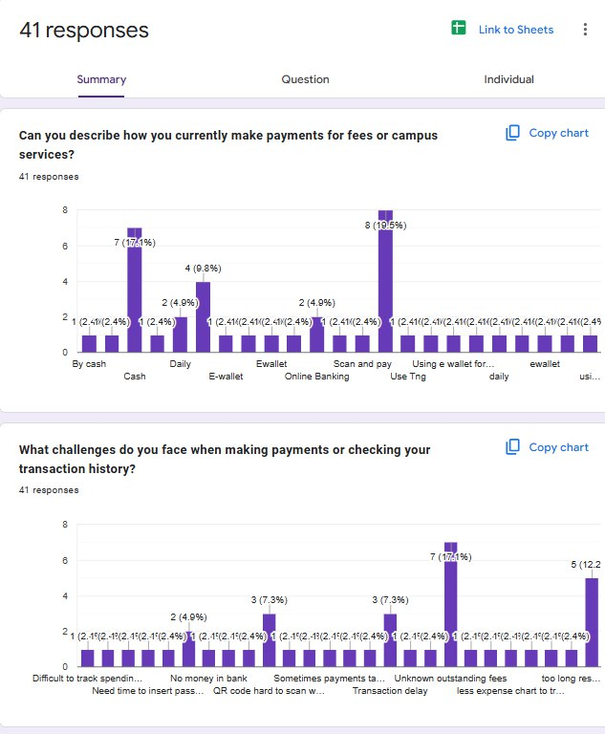
The top 3 payment methods that we receive are Tng, cash and other e-wallet.
- What challenges do you face when making payments or checking your transaction history?
The challenges that the UTM students face when making payments or checking their transaction history are unknown outstanding fees, transaction delay and the problem of scanning the QR code.

- Would you like to receive real-time notifications after every transaction?
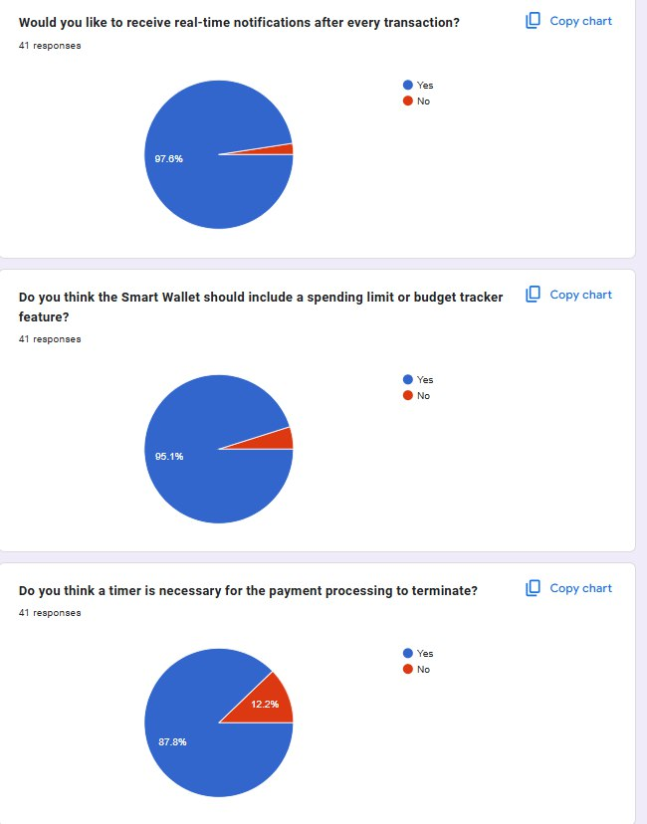
For this question, most UTM students agree that the smart wallet system needs to send real-time notifications after every transaction.
- Do you think the Smart Wallet should include a spending limit or budget tracker feature?
Most users suggest the smart wallet should include a spending limit or budget tracker feature.
- Do you think a timer is necessary for the payment processing to terminate?
For this question, most users agree that a timer is needed for the payment processing to terminate if it processes for a long time but no response.

Brainstorm

Brainstorm Creative Design

1. Auto-Terminate Payment Timer
Adds a countdown timer during payment sessions and automatically cancels incomplete transactions. This prevents timeout errors, failed payments, or accidental double charges.

2. Smart Daily Limit Guard
Allows users to set personalized daily or weekly spending limits. The system sends real time notifications when users are nearing their spending cap, promoting better financial control.

3. AI Assistant
An intelligent assistant powered by machine learning that analyzes users’ spending behavior and provides personalized financial suggestions.
It also serves as a virtual guide, helping users navigate wallet functions and solve issues efficiently.

4. Outstanding Fee Radar
Automatically scans university financial systems to detect any unpaid or upcoming fees. It alerts students promptly, helping them avoid late payments or account holds.

5. Goal-Based Wallet
Enables users to create separate “pockets” or sub accounts for specific savings goals such as books, trips, or meals. This feature encourages better money management and saving habits.

6. Campus Sync Integration
Links the Smart Wallet with key university systems such as the student ID, hostel management, library, and cafeteria. This provides a seamless, all in one payment experience and enhances fee transparency.

7. Transaction Details Display
Displays complete transaction information, including date, time, amount, recipient, payment method, and transaction ID. This enhances transparency and allows users to verify each transaction easily.

8. Favourite Transfer Feature
Lets users mark frequent recipients as “favourites” which enables faster and easier future transfers without re-entering details.

9. Preferred Payment Method Setting
Allows users to select and save their preferred payment method such as debit card or e-wallet for quicker and smoother checkout experiences.

